Ideation Phase
Empathize & Discover

Date | 25 Feb 2026
Team ID | LTVIP2026TMIDS81127
Project Name | Your Center for Skill Enhancement
Maximum Marks | 4 Marks

Empathy Map Canvas:
An empathy map is a simple, easy-to-digest visual that captures knowledge about a user’s behaviours, needs, emotions, and attitudes.
It helps teams understand their users more deeply.
To create meaningful solutions, we must first understand:
- Who the user is
- What they think, feel, say, and do
- What challenges they face
- What motivates them
This Empathy Map Canvas is designed for your project:
Example:
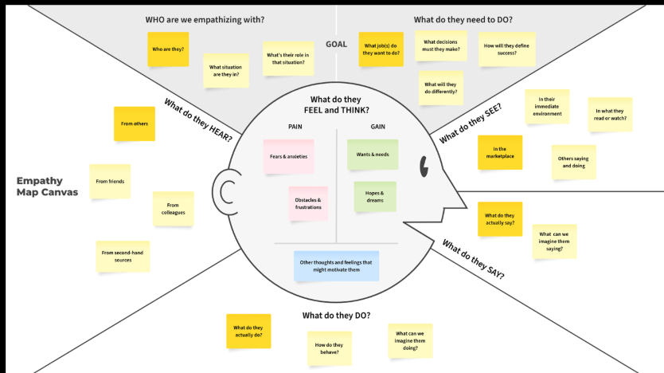

Reference: https://www.mural.co/templates/empathy-map-canvas

Example:
